***Approval Workflow with participant step***

***REQUIRED THINGS TO BE CREATED BEFORE:-***

**USED FOR STEP 1 :-** Logs are needed to be created for bad word validation.

**USED FOR STEP 2 :-**A AEM User needed to be created under <http://localhost:4502/mnt/overlay/granite/security/content/v2/usereditor.html>   
Add this created user in step 2 (participant step) - Used to send a notifcation task to that user

**USED FOR STEP 3 :-**

A system user needed to be created in system console in order to access through the JCR. I created a system user with name “geeksserviceuser”and gave permissions to read and write on the JCRSMTP SERVER SETTINGS NEEDED TO BE CONFIGURED BEFORE STARTING WORKFLOW (USED IN PARTICIPANT STEP-email sending to admin and other user)

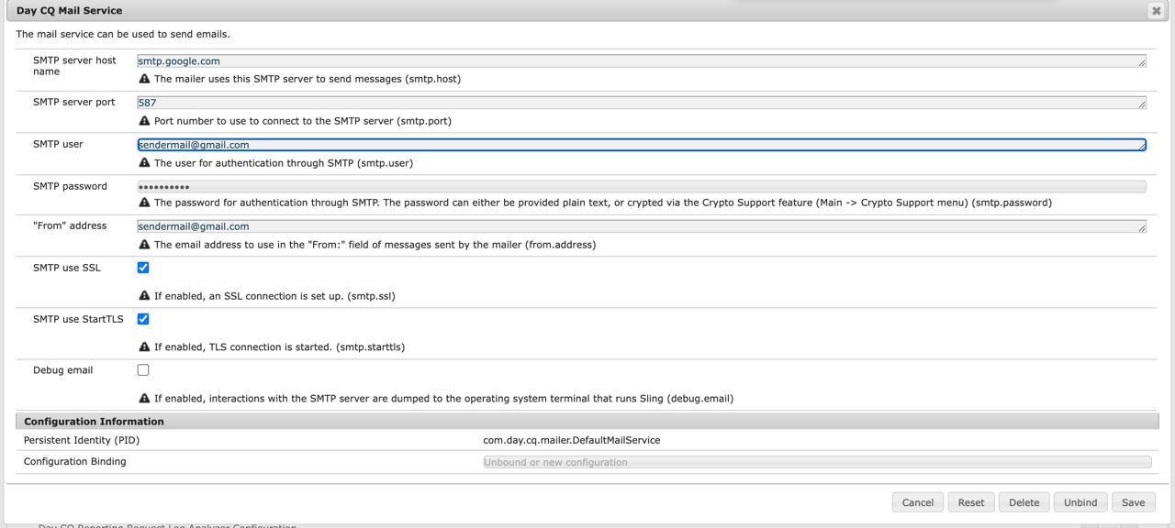

**WORKFLOW MODEL :-**

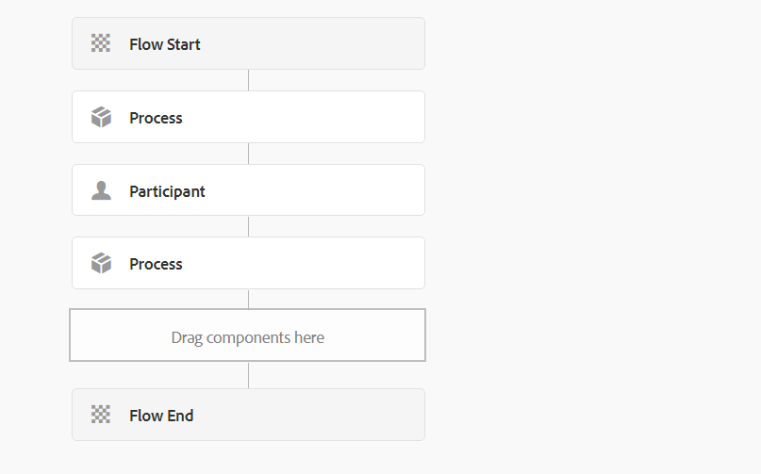

**Process Step 1:-**

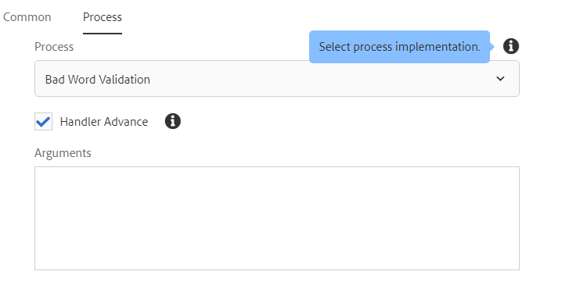

**If we select ‘Handler Advance’ , it will process to next step otherwise it stops from that step .**

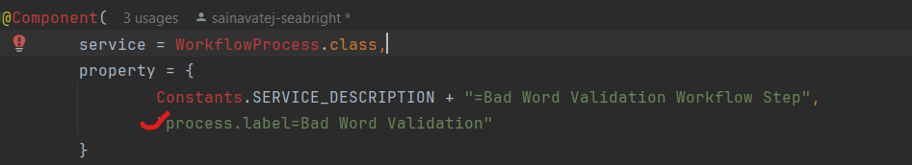





***List<String>:***

* List is a collection that can hold multiple elements, and String indicates that this list will contain elements of type String.

***Arrays.asList:***

* Arrays.asList is a static method in the java.util.Arrays class that converts an array (or a list of elements) into a fixed-size List object. This method is particularly useful for quickly creating a list with predefined values.
* Map<String, Object> authInfo = Map.*of*(ResourceResolverFactory.SUBSERVICE, "geeksserviceuser");
* resolver = resolverFactory.getServiceResourceResolver(authInfo);

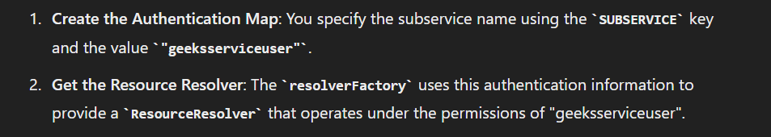

String payloadPath = (String) workItem.getWorkflowData().getPayload();

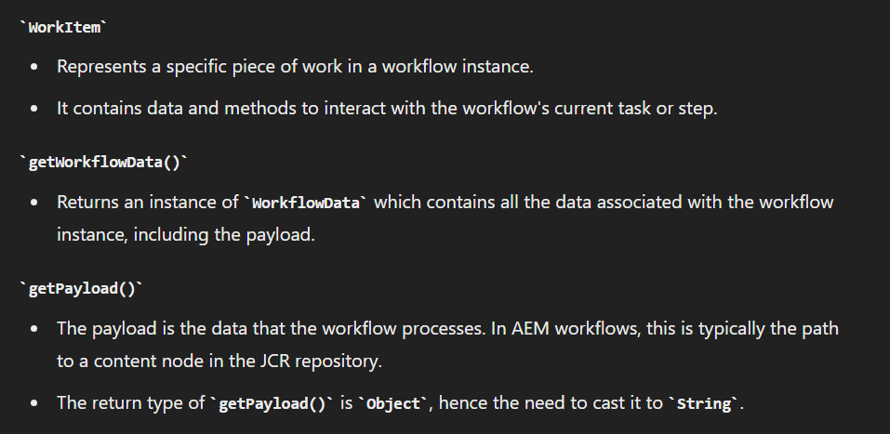

Resource resource = resolver.getResource(payloadPath);

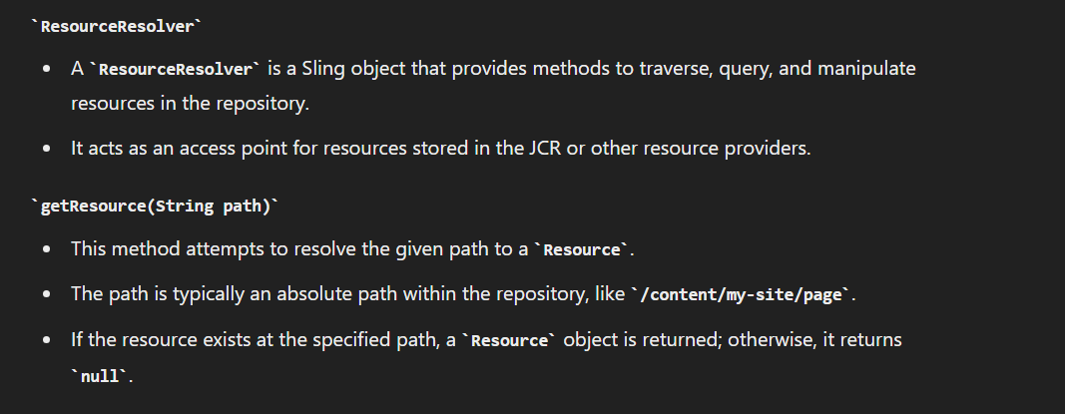

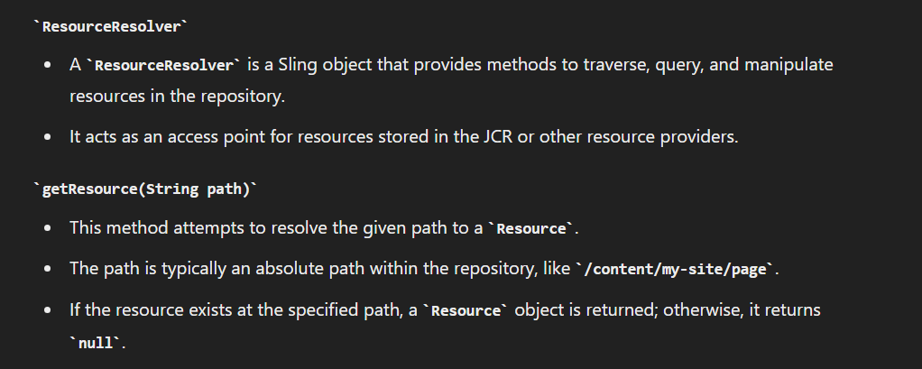

Resource contentResource = resource.getChild("jcr:content");

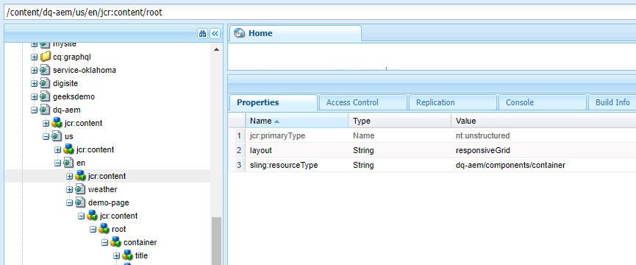

if (contentResource != null) {  
 checkForBadWords(contentResource);}

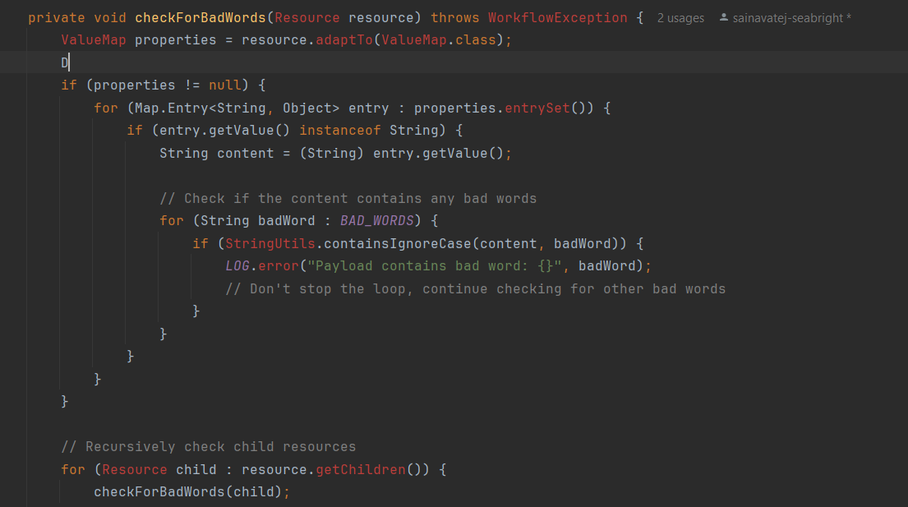

**PARTICIPANT STEP 2 :-**

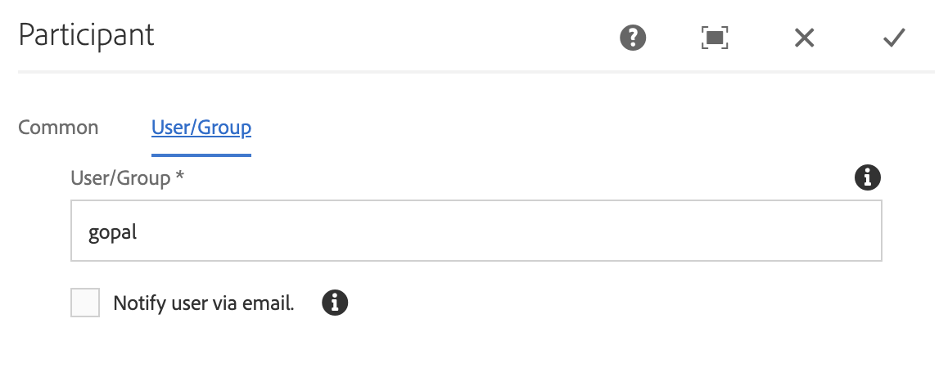

We have to select the user which we created in order to send notification of the workflow task

**PROCESS STEP 3:-**

We have to select the Process label which we gave in the back end workflow class . I gave the process step with name “Send Email notification”.

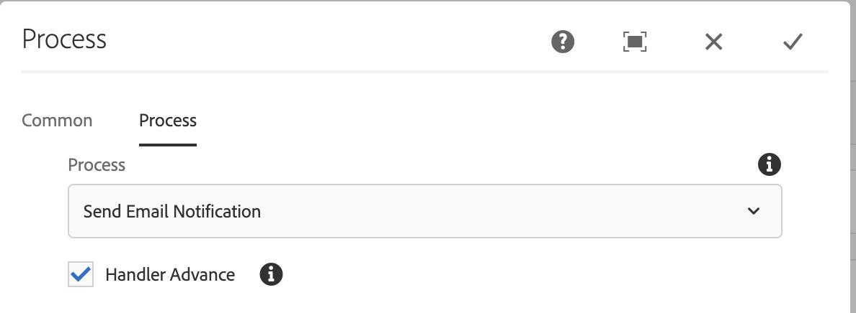

Now we have to run the workflow by selecting the payload (page)whichever we need. Select the page needed as below and click on run.

Now we have to run the workflow by selecting the payload (page)whichever we need. Select the page needed as below and click on run.

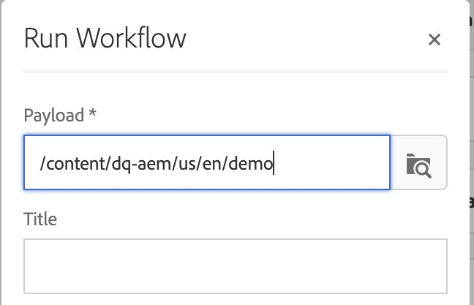

Now we need to start the workflow again in by going to the page which we selected. Select the page and click on create option which is in left up corner and click on workflow,

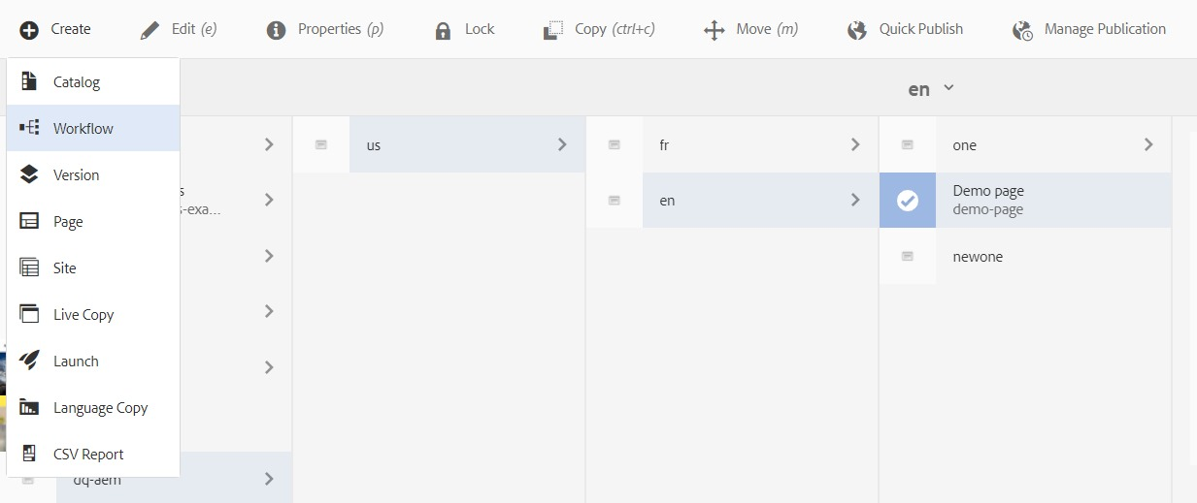

Now after clicking on create workflow now we will be gettting like below image in which we need to select the Workflow-model which we initiated the workflow. select the workflow model and also give a title related to it. and click on create.

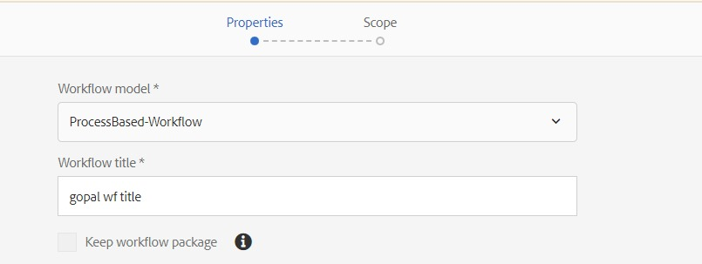

Now we will get the workflow like below ,we have to select this and click on create again.

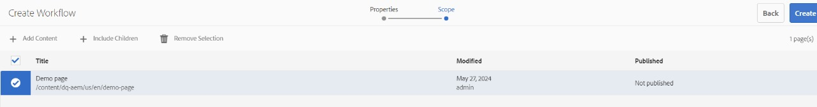

Now Workflow has been successfully started on the page, now we would have got a notification in notification bell icon on top right corner saying a workflow which is initiated,

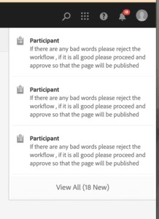

we have to select the notification(workflow task) and click on complete in order to get into the second step in workflow model.

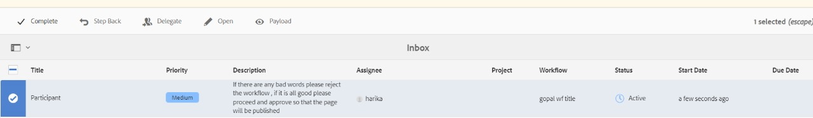

we have got the dialog box saying the next step which is going to happen next, click on ok

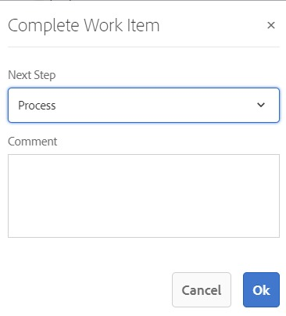

Means now the first step is completed in our workflow (which is validating any bad words are there in the payload if there are any badwords in payload it would be printed in logs accordingly which are configured accordingly) , now the next step is to send a notification to another user by using a participant step. So after completing the first step the participant step will send a notification will be sent to the another user which is configured in workflow model.

Below is the aem user which we created and also gave in participant step. So we have to login to aem in incog tab through this newly created username and password

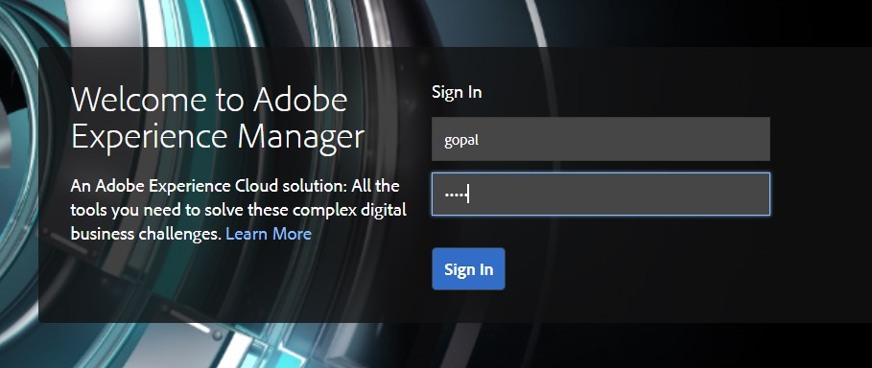

As soon as u login to this user u would see a workflow notification on bell icon on top right corner.

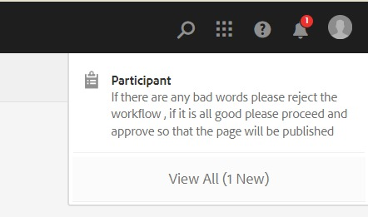

When we open it we have got a notification task of workflow which is to accept or revert back to the first step. so u can select the task and u can accept it or step back it accordingly.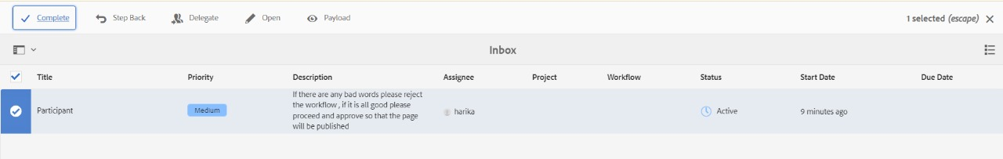

If we are ok and clicked on complete then again this dialog box will open which says the next step which is going to happen

.****

**PROCESS STEP 3:-**

Now we have completed two steps in the workflow which is bad word validation and sending a notification to the user. now the third step will happen which is send a email to the other user and also to the admin email.



This below is the process label step which we gave in backend code so this label should be appended to the process step in the workflow model.



By using the system user “geeksserviceuser” we are getting the JCR required things. we need to create this system user and give all required permisions to read and write the JCR.

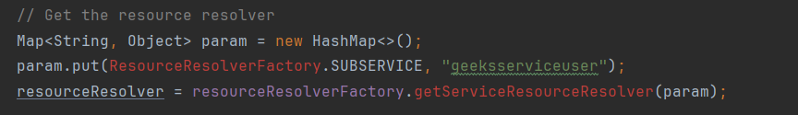

Here the user is getting the emails of the admin and other user thriugh JCR which are stored in the Home/profiles of the users.



